UNIVERSITY OF CALIFORNIA, BERKELEY
College of Engineering
Department of Electrical Engineering and Computer Sciences
EE 130/230M Spring 2013
Integrated Circuit Devices Prof. Liu & Dr. Xu
QUIZ #6
Time allotted: 25 minutes

NAME: ____SOLUTIONS______ _________________________ _________________________
(print) Last First Signature

INSTRUCTIONS:
1. Use the values of physical constants provided below.
2. SHOW YOUR WORK, & write legibly!
3. Underline or box numerical answers and SPECIFY UNITS where appropriate.

Problem 1 [12 points]
- Indicate how a long-channel MOSFET’s performance parameters would be affected (i.e. check the appropriate column) if the channel/body doping is increased by a factor of 2. Explain briefly.
Parameter | [1 pt each]: Value would |  |  | Brief explanation [2 pts each]
 | increase | decrease | not change
Subthreshold swing, S  [units: mV/dec] |  |  |  | W_{T} ∝ 1/(√N_{B}) decreases  C_{dep} ∝ 1/W_{T} increases  S ∝ [1 + C_{dep}/C_{oxe}] increases  Capacitive coupling between gate and channel is degraded due to increased coupling between body and channel
Transconductance, g_{m}  [units: A/V] |  |  |  | V_{T} increases  Gate overdrive (V_{GS}−V_{T}) decreases  Also, effective mobility μ_{eff} decreases due to increased average electric field within the inversion-layer channel, and the bulk charge factor m increases
- What is a retrograde channel doping profile, and why is it used in short-channel MOSFETs? [3 pts]

A retrograde profile comprises a lightly doped surface region and a heavily doped sub-surface region.

It is used to suppress punchthrough with less detrimental impact on V_{T} and μ_{eff}, as compared with a uniformly heavily doped channel.

- What is the MOSFET short-channel effect, what causes it, and why is it undesirable? [3 pts]

The short-channel effect refers to a reduction in |V_{T}| with decreasing channel length L, caused by depletion of the channel region near to the source and drain junctions. This effect is undesirable because it results in significant V_{T} variation (and hence significant variations in on-state drive current and off-state leakage current) with process-induced channel-length variations.
Problem 2 [8 points]
Consider a short n-channel MOSFET with W = 1 μm, L = 0.1 μm, C_{oxe} = 10⁻⁶ F/cm², and m = 1.
- Estimate the drain saturation voltage (V_{Dsat}) for V_{GS} − V_{T} = 1 V, assuming μ_{eff} = 400 cm²/V⋅s. [3 pts]
(Recall that v_{sat} = 8×10⁶ cm/s for electrons in Si.)

E_{sat} = 2v_{sat}/μ_{eff} = 2⋅(8×10⁶ cm/s)/(400 cm²/V⋅s) = 4×10⁴ V/cm

1/E_{sat}L = 1/(4×10⁴ V/cm)(10⁻⁵ cm) = 1/0.4 = 2.5 V⁻¹
m/(V_{GS} − V_{T}) = 1 V⁻¹

1/V_{Dsat} = 1/E_{sat}L + m/(V_{GS} − V_{T}) = 2.5 + 1 = 3.5 V⁻¹ V_{Dsat} = 1/3.5 ≅ 0.3 V

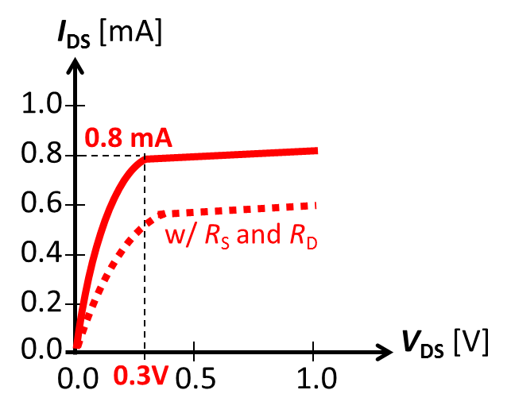

- Draw the I_{D}-V_{DS} curve for V_{GS} − V_{T} = 1 V on the axes provided.
Indicate V_{Dsat} and the value of I_{D} at V_{DS} = V_{Dsat}. [3 pts]
Since E_{sat}L=0.4V is much smaller than (V_{GS}-V_{T})/m = 1V, we can use the short-channel I-V equation to estimate I_{Dsat}:
I_{Dsat} = Wv_{sat}C_{oxe}(V_{GS} − V_{T})
= (10⁻⁴ cm)(8×10⁶ cm/s)(10⁻⁶ F/cm²)(1 V)
= 8×10⁻⁴ A = 0.8 mA

More accurately, using the full MOSFET I-V equation:
I_{Dsat} = (W/2mL)μ_{eff} C_{oxe}(V_{GS} − V_{T})²/[1+(V_{GS} − V_{T})/(mE_{sat}L)]
= (1/2∙0.1)(400)(10⁻⁶)(1)²/[1+(1/0.4)] ≅ 0.6 mA
- Draw another I_{D}-V_{DS} curve to qualitatively show how a large source resistance and large drain resistance would affect the I-V characteristic. [2 pts]

Problem 3 [5 points]
Suppose that a BJT with the common-emitter output characteristics shown below is operating under applied voltages such that I_{C} ≅ 1 mA with the following energy band diagram:
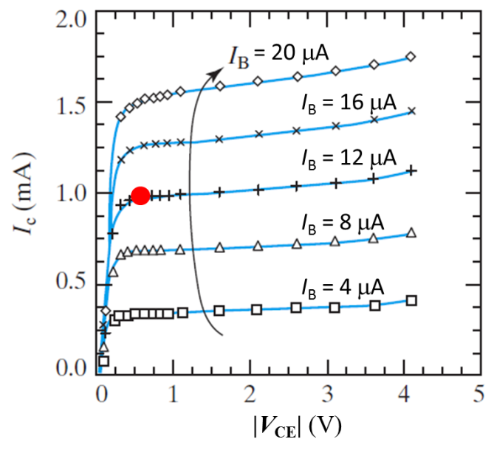
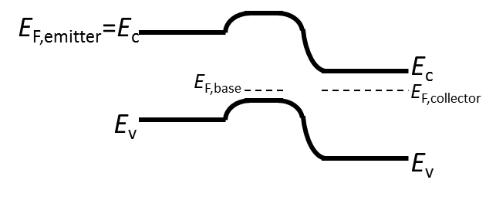

(a) What type of BJT is this (PNP or NPN)? [1 pt]

This is an NPN BJT.

(b) Indicate (by drawing a large dot) the operating point of this BJT on the I-V plot above. [2 pts]

Since V_{CB} = 0 V this BJT is operating at the edge of saturation.

(c) Estimate the d.c. current gain, β_{dc}. [2 pts]

For I_{C} = 1 mA, I_{B} = 12 uA β_{dc} = I_{C}/I_{B} = 10⁻³/12×10⁻⁶ ≅ 83

