CS152

Computer Architecture and Engineering

Memory Consistency and

Cache Coherence
Assigned April 11 Problem Set #5 Due April 23
http://inst.eecs.berkeley.edu/~cs152/sp16
The problem sets are intended to help you learn the material, and we encourage you to collaborate with other students and to ask questions in discussion sections and office hours to understand the problems. However, each student must turn in their own solutions to the problems.

The problem sets also provide essential background material for the quizzes. The problem sets will be graded primarily on an effort basis, but if you do not work through the problem sets you are unlikely to succeed at the quizzes! We will distribute solutions to the problem sets on the day the problem sets are due to give you feedback. Homework assignments are due at the beginning of class on the due date. Homework will not be accepted once solutions are handed out.

Problem P5.1: Sequential Consistency

For this problem we will be using the following sequences of instructions. These are small programs, each executed on a different processor, each with its own cache and register set. In the following R is a register and X is a memory location. Each instruction has been named (e.g., B3) to make it easy to write answers.

Assume data in location X is initially 0.
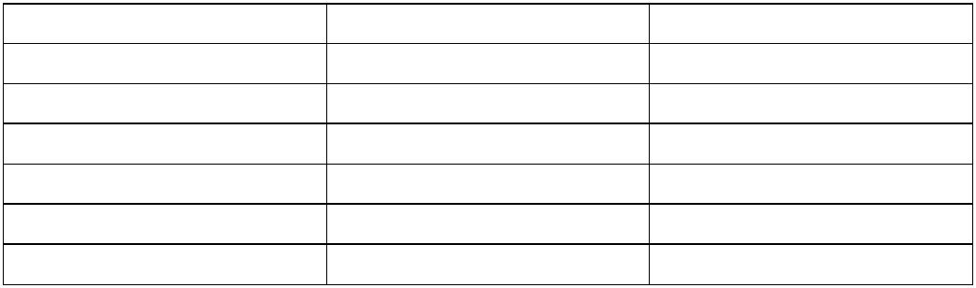
Processor A | Processor B | Processor C
A1: ST X, 1 | B1: R := LD X | C1: ST X, 6
A2: R := LD X | B2: R := ADD R, 1 | C2: R := LD X
A3: R := ADD R, R | B3: ST X, R | C3: R := ADD R, R
A4: ST X, R | B4: R:= LD X | C4: ST X, R
 | B5: R := ADD R, R
 | B6: ST X, R

For each of the questions below, please circle the answer and provide a short explanation assuming the program is executing under the SC model. No points will be given for just circling an answer!

Problem P5.1.A
Can X hold value of 4 after all three threads have completed? Please explain briefly.

Yes / No

Problem P5.1.B
Can X hold value of 5 after all three threads have completed?

Yes / No

Problem P5.1.C
Can X hold value of 6 after all three threads have completed?

Yes / No

Problem P5.1.D
For this particular program, can a processor that reorders instructions but follows local dependencies produce an answer that cannot be produced under the SC model?

Yes / No

Problem P5.2: Synchronization Primitives

One of the common instruction sequences used for synchronizing several processors are the LOAD RESERVE/STORE CONDITIONAL pair (from now on referred to as LdR/StC pair). The LdR instruction reads a value from the specified address and sets a local reservation for the address. The StC attempts to write to the specified address provided the local reservation for the address is still held. If the reservation has been cleared the StC fails and informs the CPU.

Problem P5.2.A
Describe under what events the local reservation for an address is cleared.

Problem P5.2.B
Is it possible to implement LdR/StC pair in such a way that the memory bus is not affected, i.e., unaware of the addition of these new instructions? Explain

Problem P5.2.C
Give two reasons why the LdR/StC pair of instructions is preferable over atomic read-test-modify instructions such as the TEST&SET instruction.

Problem P5.3: Relaxed Memory Models

The following code implements a seqlock, which is a reader-writer lock that supports a single writer and multiple readers. The writer never has to wait to update the data protected by the lock, but readers may have to wait if the writer is busy. We use a seqlock to protect a variable that holds the current time. The lock is necessary because the variable is 64 bits and thus cannot be read or written atomically on a 32-bit system.

The seqlock is implemented using a sequence number, seqno, which is initially zero. The writer begins by incrementing seqno. It then writes the new time value, which is split into the 32-bit values time_lo and time_hi. Finally, it increments seqno again. Thus, if and only if seqno is odd, the writer is currently updating the counter.

The reader begins by waiting until seqno is even. It then reads time_lo and time_hi. Finally, it reads seqno again. If seqno didn't change from the first read, then the read was successful; otherwise, the read is retried.

This code is correct on a sequentially consistent system, but on a system with a fully relaxed memory model it may not be. Insert the minimum number of memory fences to make the code correct on a system with a relaxed memory model. To insert a fence, write the needed fence (Membar_{LL}, Membar_{LS}, Membar_{SL,} Membar_{SS}) in between the lines of code below.

Writer | Reader
LOAD R_{seqno},(seqno)  ADD R_{seqno}, R_{seqno}, 1  STORE (seqno), R_{seqno}  STORE (time_lo), R_{time_lo}  STORE (time_hi), R_{time_hi}  ADD Rseqno, Rseqno, 1  STORE (seqno), R_{seqno} | Loop:  LOAD R_{seqno_before}, (seqno)  IF(R_{seqno_before} & 1)  goto Loop  LOAD R_{time_lo}, (time_lo)  LOAD R_{time_hi}, (time_hi)  LOAD R_{seqno_after}, (seqno)  IF(R_{seqno_before} != R_{seqno_after})  goto Loop

Problem P5.4: Locking Performance

While analyzing some code, you find that a big performance bottleneck involves many threads trying to acquire a single lock.

Conceptually, the code is as follows:

int mutex = 0;

while( true )
{
noncritical_code( );

lock( &mutex ); critical_code( ); unlock( &mutex );
}

Assume for all questions that our processor is using a directory protocol, as described in Handout #6.

Test&Set Implementation

First, we will use the atomic instruction test_and_set to implement the lock(mutex) and unlock(mutex) functions.

In C, the instruction has the following function prototype:

int return_value = test_and_set(int* maddr);

Recall that test_and_set atomically reads the memory address maddr and writes a 1 to the location, returning the original value.

Using test_and_set, we arrive at the following first-draft implementation for the lock() and unlock() functions:

void inline lock(int* mutex_ptr)
{
while(test_and_set(mutex_ptr) == 1);
}

void inline unlock(int* mutex_ptr)
{
*mutex_ptr = 0;
}
Problem P5.4.A Test&Set, The Initial Acquire
Let us analyze the behavior of Test&Set while running 1,000 threads on a 1,000 cores.

Consider the following scenario: At the start of the program, the lock is invalid in all caches. Then, every thread executes Test&Set once. The first thread wins the lock, while the other threads will find that the lock is taken. How many invalidation messages must be sent when all 1,000 threads execute Test&Set once?

Invalidations _______

Problem P5.4.B Test&Set, Spinning
While the first thread is in the critical section (the “winning thread”), the remaining threads continue to execute Test&Set, attempting to acquire the lock. Each waiting thread is able to execute Test&Set five times before the winning thread frees the lock. How many invalidation messages must be sent while the winning thread was executing the critical section?

Invalidations _______

Problem P5.4.C Test&Set, Freeing the Lock
How many invalidation messages must be sent when the winning thread frees the lock? Assume the critical section is very long, and all 999 other threads have been waiting to acquire the lock.

Invalidations _______
Test&Test&Set Implementation

Since our analysis from the previous parts show that a lot of invalidation messages must be sent while waiting for the lock to be freed, let us instead use a regular load alongside the atomic instruction test&set to implement the mutex lock.

void inline lock(int* mutex_ptr)
{
while((*mutex_ptr == 1) || test&set(mutex_ptr) == 1);
}

void inline unlock(int* mutex_ptr)
{
*mutex_ptr = 0;
}

(Note: the loop evaluation is short-circuited if the first part is true; thus, test&set is only executed if (*mutex_ptr) does not equal 1).

Problem P5.4.D Test&Set&Set, The Initial Acquire
Let us analyze the behavior of Test&Test&Set while running 1,000 threads on a 1,000 cores.

Consider the following scenario: At the start of the program, the lock is invalid in all caches. Then every thread performs the first Test (reading mutex_ptr) once. After every thread has performed the first Test (which evaluates to False, because mutex == 0), each thread then executes the atomic Test&Set once. Naturally, only one thread wins the lock. How many invalidation messages must be sent in this scenario?

Invalidations _______

Problem P5.4.E Test&Set&Set, Spinning
While the first thread is in the critical section, the remaining threads continue to execute Test&Test&Set. Each waiting thread is able to execute Test&Test&Set five times before the winning thread frees the lock. How many invalidation messages must be sent while the winning thread was executing the critical section?

Invalidations _______

Problem P5.4.F Test&Set&Set, Freeing the Lock
How many invalidation messages must be sent when the winning thread frees the lock for the Test&Test&Set implementation? Assume the critical section is very long, and all 999 other threads have been waiting to acquire the lock.

Invalidations _______
Problem P5.5: Directory-based Cache Coherence Update Protocols

In Handout #6, we examined a cache-coherent distributed shared memory system. Ben wants to convert the directory-based invalidate cache coherence protocol from the handout into an update protocol. He proposes the following scheme.

Caches are write-through, not write allocate. When a processor wants to write to a memory location, it sends a WriteReq to the memory, along with the data word that it wants written. The memory processor updates the memory, and sends an UpdateReq with the new data to each of the sites caching the block, unless that site is the processor performing the store, in which case it sends a WriteRep containing the new data.

If the processor performing the store is caching the block being written, it must wait for the reply from the home site to arrive before storing the new value into its cache. If the processor performing the store is not caching the block being written, it can proceed after issuing the

WriteReq.

Ben wants his protocol to perform well, and so he also proposes to implement silent drops. When a cache line needs to be evicted, it is silently evicted and the memory processor is not notified of this event.

Note that WriteReq and UpdateReq contain data at the word-granularity, and not at the block-granularity. Also note that in the proposed scheme, memory will always have the most up-to-date data and the state C-exclusive is no longer used.

As in the lecture, the interconnection network guarantees that message-passing is reliable, and free from deadlock, livelock, and starvation. Also as in the lecture, message-passing is FIFO.

Each home site keeps a FIFO queue of incoming requests, and processes these in the order received.

Problem P5.5.A Sequential Consistency
Alyssa claims that Ben’s protocol does not preserve sequential consistency because it allows two processors to observe stores in different orders. Describe a scenario in which this problem can occur.

Problem P5.5.B State Transitions
Noting that many commercial systems do not guarantee sequential consistency, Ben decides to implement his protocol anyway. Fill in the following state transition tables (Table P5.5-1 and Table P5.5-2) for the proposed scheme. (Note: the tables do not contain all the transitions for the protocol).

No. | Current State | Event Received |  | Next State | Action
1 | C-nothing | Load |  | C-transient | ShReq(id, Home, a)
2 | C-nothing | Store
3 | C-nothing | UpdateReq
4 | C-shared | Load |  | C-shared | processor reads cache
5 | C-shared | Store
6 | C-shared | UpdateReq
7 | C-shared | (Silent drop) |  |  | Nothing
8 | C-transient | ShRep |  |  | data → cache, processor reads cache
9 | C-transient | WriteRep
10 | C-transient | UpdateReq
 |  |  | Table P5.5-1: Cache State Transitions
No. | Current State |  | Message | Next State | Action
 |  |  | Received
1 | R(dir) & id ∉ dir |  | ShReq | R(dir + {id}) | ShRep(Home, id, a)
2 | R(dir) & id ∉ dir |  | WriteReq
3 | R(dir) & id ∈ dir |  | ShReq |  | ShRep(Home, id, a)
4 | R(dir) & id ∈ dir |  | WriteReq
 |  |  | Table P5.5-2: Home Directory State Transitions (N = “is not in”)
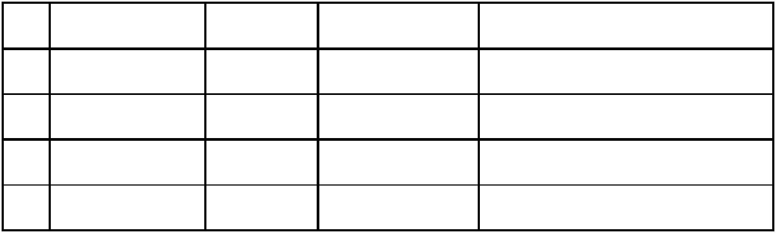

Problem P5.5.C UpdateReq
After running a system with this protocol for a long time, Ben finds that the network is flooded with UpdateReqs. Alyssa says this is a bug in his protocol. What is the problem and how can you fix it?

Problem P5.5.D FIFO Assumption
FIFO message passing is a necessary assumption for the correctness of the protocol. If the network were non-FIFO, it becomes possible for a processor to never see the result of another processor’s store. Describe a scenario in which this problem can occur.

Problem P5.6: Snoopy Cache Coherent Shared Memory

In this problem, we investigate the operation of the snoopy cache coherence protocol in Handout #7. The following questions are to help you check your understanding of the coherence protocol. You do not need to answer these for credit.

- Explain the differences between CR, CI, and CRI in terms of their purpose, usage, and the actions that must be taken by memory and by the different caches involved.
- Explain why WR is not snooped on the bus.
- Explain the I/O coherence problem that CWI helps avoid.

Problem P5.6.A Where in the Memory System is the Current Value
In Table P5.6-1, P5.6-2, and P5.6-3, column 1 indicates the initial state of a certain address X in a cache. Column 2 indicates whether address X is currently cached in any other cache. (The “cached” information is known to the cache controller only immediately following a bus transaction. Thus, the action taken by the cache controller must be independent of this signal, but state transition could depend on this knowledge.) Column 3 enumerates all the available operations on address X, either issued by the CPU (read, write), snooped on the bus (CR, CRI, CI. etc), or initiated by the cache itself (replacement). Some state-operation combinations are impossible; you should mark them as such. (See the first table for examples). In columns 6, 7, and 8 (corresponding to this cache, other caches and memory, respectively), check all possible locations where up-to-date copies of this data block could exist after the operation in column 3 has taken place and ignore column 4 and 5 for now. Table P5.6-1 has been completed for you. Make sure the answers in this table make sense to you.

Problem P5.6.B MBus Cache Block State Transition Table
In this problem, we ask you to fill out the state transitions in Column 4 and 5. In column 5, fill in the resulting state after the operation in column 3 has taken place. In column 4, list the necessary MBus transactions that are issued by the cache as part of the transition. Remember, the protocol should be optimized such that data is supplied using CCI whenever possible, and only the cache that owns a line should issue CCI.

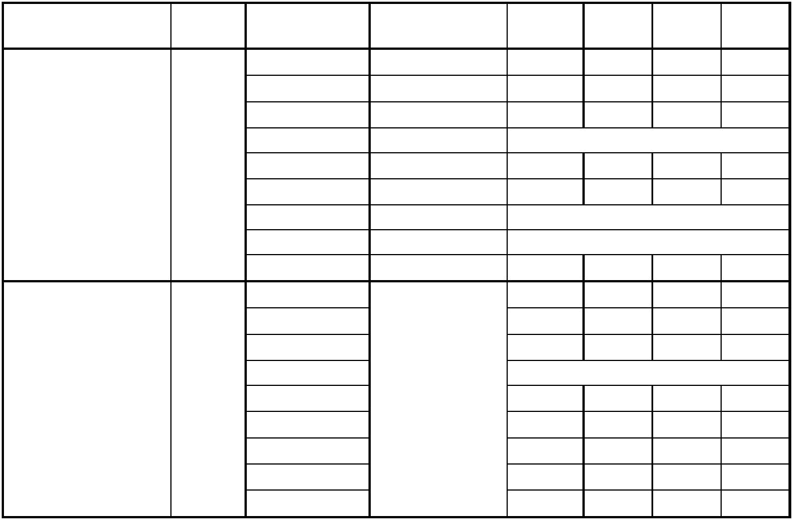
initial state | other | ops | actions by this | final
 | cached |  | cache | state
Invalid | no | none | none | I
 |  | CPU read | CR | CE
 |  | CPU write | CRI | OE
 |  | replace | none
 |  | CR | none | I
 |  | CRI | none | I
 |  | CI | none
 |  | WR | none
 |  | CWI | none | I
Invalid | yes | none |  | I
 |  | CPU read |  | CS
 |  | CPU write |  | OE
 |  | replace | same
 |  | CR | as | I
 |  | CRI | above | I
 |  | CI |  | I
 |  | WR |  | I
 |  | CWI |  | I
initial state | other | ops | actions by this | final
 | cached |  | cache | state
cleanExclusive | no | none | none | CE
 |  | CPU read
 |  | CPU write
 |  | replace
 |  | CR |  | CS
 |  | CRI
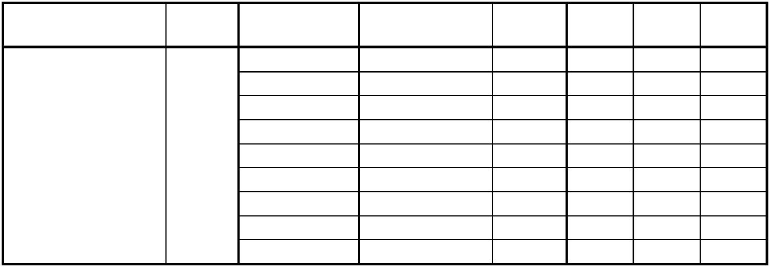
CI

WR

CWI

Table P5.6-1

this | other | mem
cache | caches
 |  | √
√ |  | √
√
Impossible
 | √ | √
 | √
Impossible
Impossible
 |  | √
 | √ | √
√ | √ | √
√
Impossible
 | √ | √
 | √
 | √
 | √ | √
 |  | √
this | other | mem
cache | caches

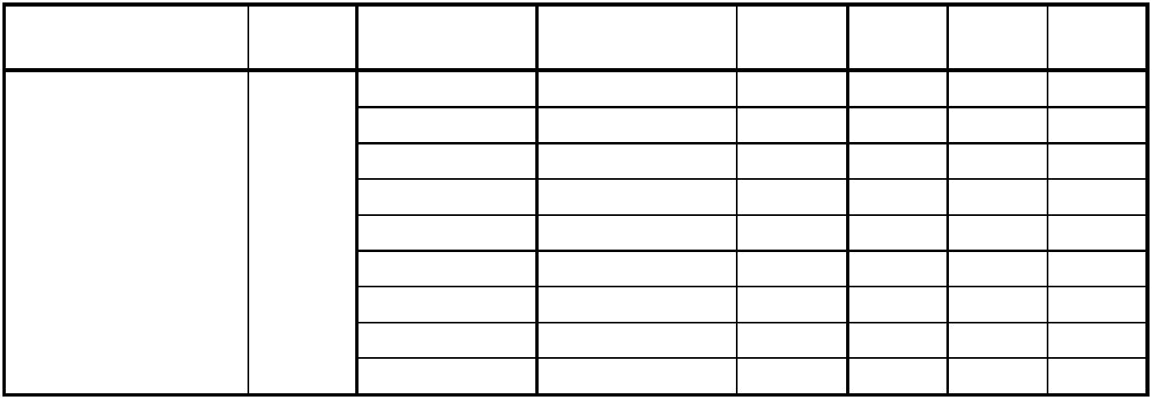
initial state | other | ops | actions by this | final | this | other | mem
 | cached |  | cache | state | cache | caches
ownedExclusive | no | none | none | OE
 |  | CPU read
 |  | CPU write
 |  | replace
 |  | CR |  | OS
 |  | CRI
 |  | CI
 |  | WR
 |  | CWI
initial state | other | ops | actions by this | final | this | other | mem
 | cached |  | cache | state | cache | caches
cleanShared | no | none | none | CS
 |  | CPU read
 |  | CPU write
 |  | replace
 |  | CR
 |  | CRI
 |  | CI
 |  | WR
cleanShared |  | CWI
cleanShared | yes | none
 |  | CPU read
 |  | CPU write
 |  | replace | same
 |  | CR | as
 |  | CRI | above
 |  | CI
 |  | WR
 |  | CWI
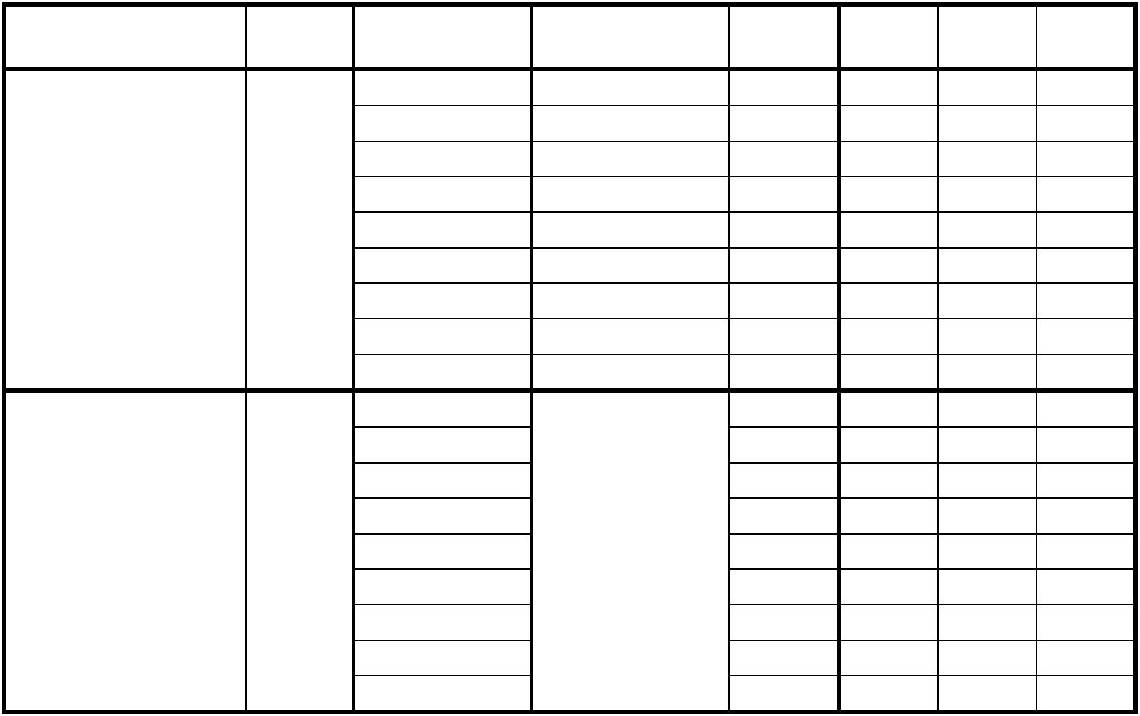
Table P5.6-2

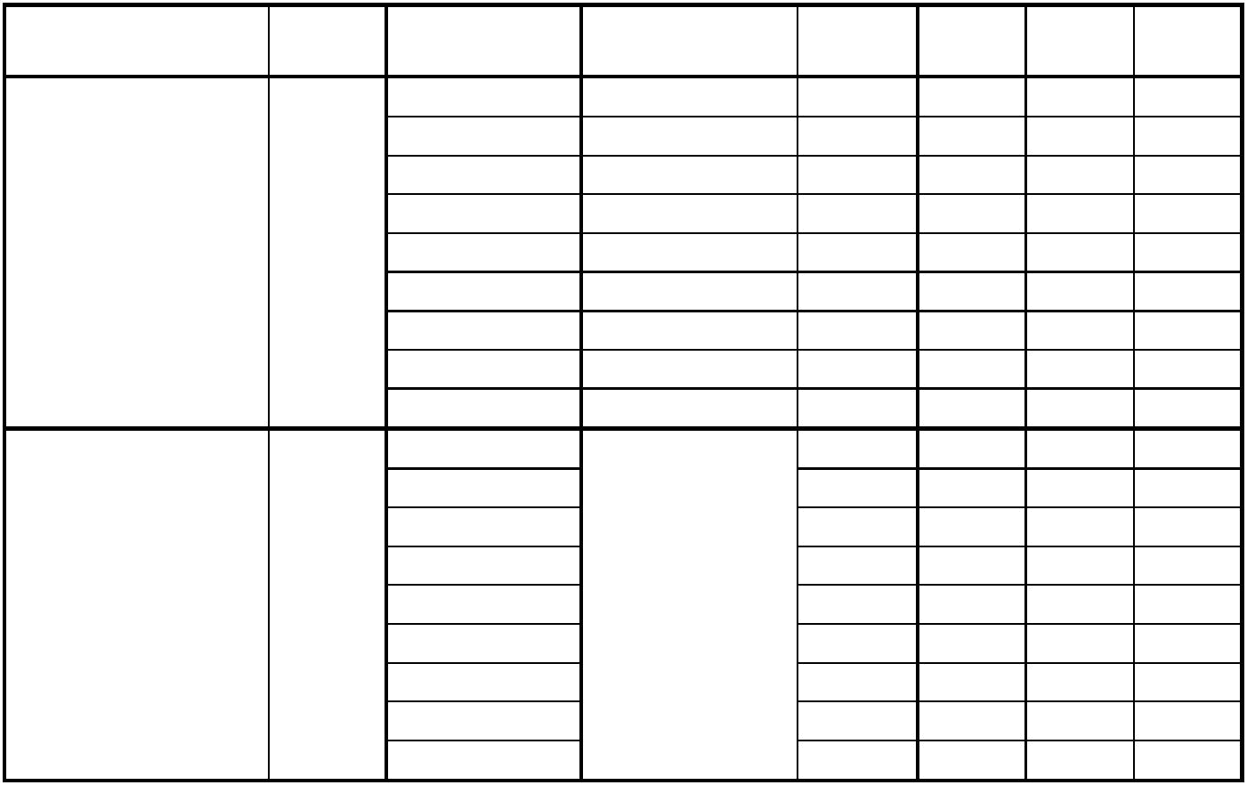
initial state | other | ops | actions by this | final | this | othermem
 | cached |  | cache | state | cache | caches
ownedShared | no | none | none | OS
 |  | CPU read
 |  | CPU write
 |  | replace
 |  | CR
 |  | CRI
 |  | CI
 |  | WR
ownedShared |  | CWI
ownedShared | yes | none
 |  | CPU read
 |  | CPU write
 |  | replace | same
 |  | CR | as
 |  | CRI | above
 |  | CI
 |  | WR
 |  | CWI
Table P5.6-3

